**Version of HTML:**

1. HTML 2.0
2. HTML 3.2
3. HTML 4.0
4. HTML 5.0

**TAGS:**

1. <sub></sub>
2. <sup></sup>
3. <u></u>
4. <strong></strong>
5. <pre></pre>
6. <s></s>
7. <mark></mark>
8. <abbr tittle=””></abbr>
9. <a></a> 🡺 attributes of anker tag is href=””, target, download, rel, tittle, id , class
10. What is absolute path and relative path.
11. Html entities 🡺 in html we use some code for special characters.
12. For showing special character in html element we have 3 method. First is Html entity, Second is Hexadecimal numeric refrence and third is Decimal numeric refrence.
13. <img src=”” alt = “” width=”” height=”” tittle=”” loading=”lazy” /> 🡺 for image responsive we take height =”auto” and width = 100%.
14. alt=”” attribute in image tag is very important. Without this your website cant rank.
15. For making part of the image clickable we use 🡺 <img usemap=”#id” /> and <map name=”id”><area shape=”circle” coordinates=”” href=”” alt=”” /></map>
16. srcset=”” attribute in image tag 🡺 The srcset attribute lets you define multiple image sources for different device resolutions or screen widths.  
    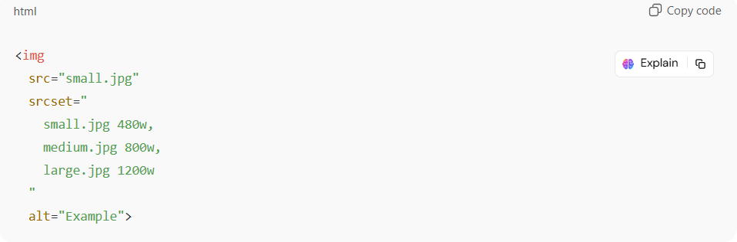
17. sizes = “” attribute in image tag 🡺 The sizes attribute tells the browser how much space (width) the image will take up in different screen sizes.  
    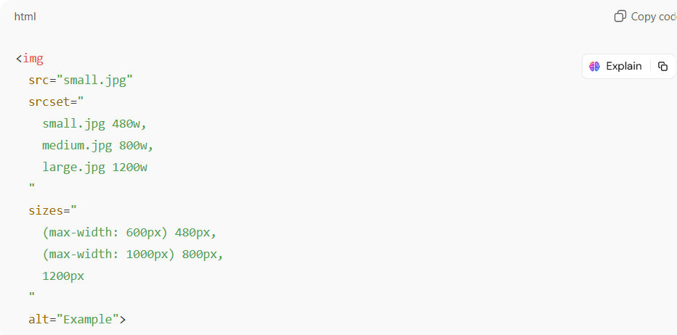
18. picture tag:   
    <picture>  
     <source srcset=”” type=””/>  
     <source srcset=”” type=””/>  
     <img src=”” alt=”” />  
    </picture>  
    We will use same image which we used in img tag in all sources tag in picture tag.  
    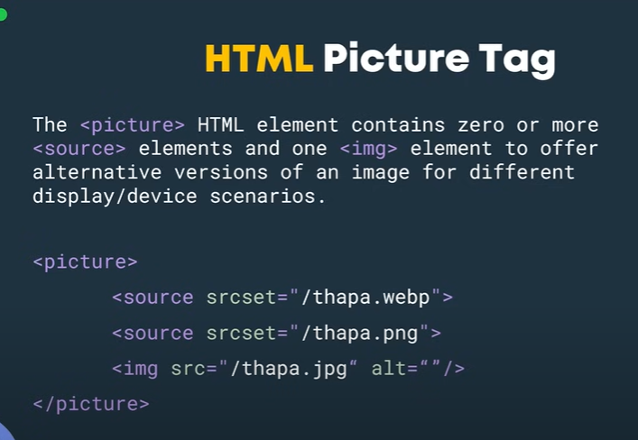
19. figure tag:  
    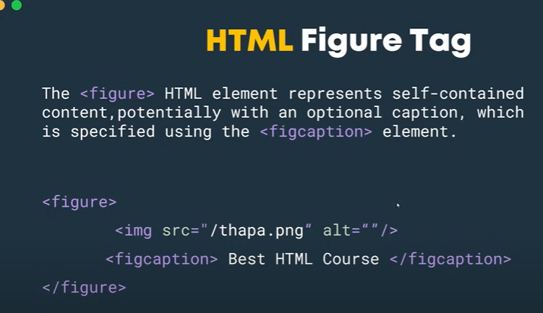
20. ul and ol: we also use start attribute in ol.  
    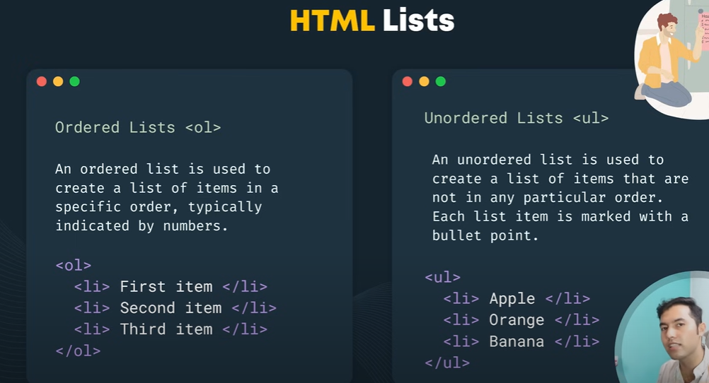

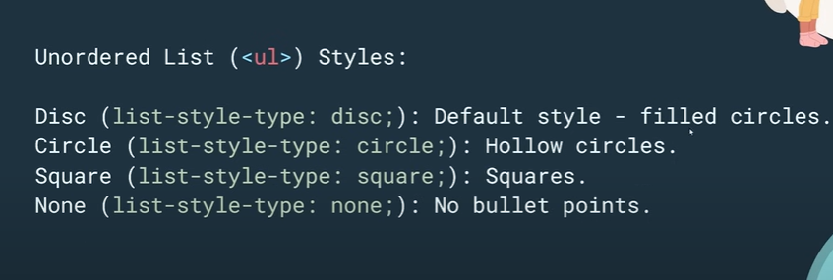

1. table tag in html:

<table></table>,<thead></thead>, <tbody></tbody>, <tr></tr>, <th></th>, <td></td>

1. iframe tag 🡺 use for embedding other site in the current site.
2. Audio tage element:  
   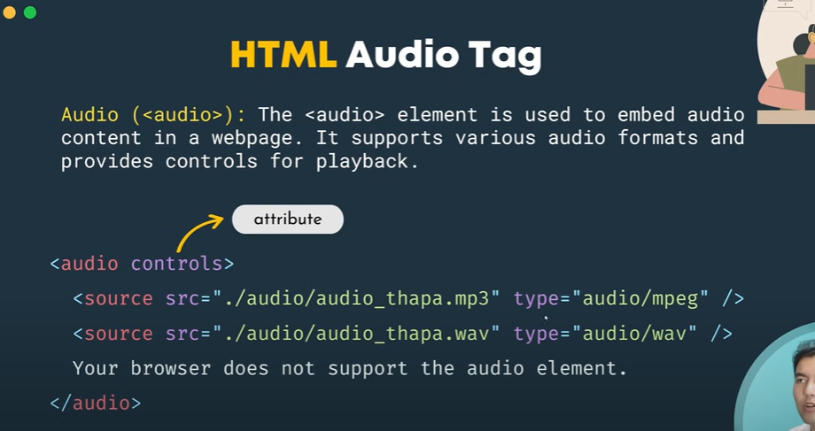  
   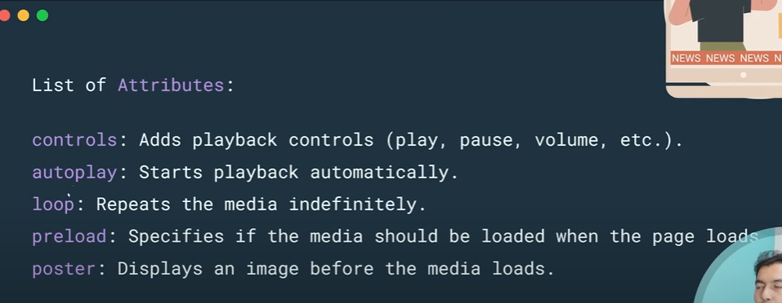
3. Video tag:   
   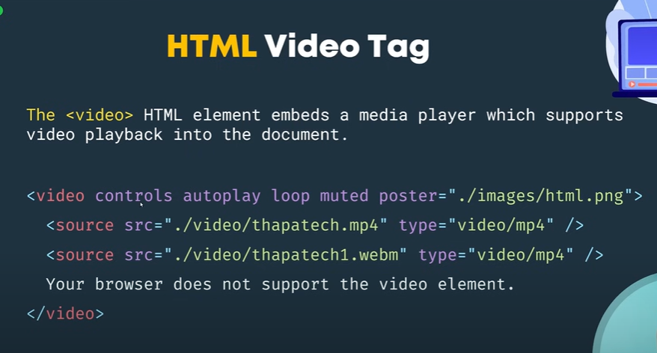
4. Form tag?
5. What is sementaic element?
6. Meta data :  
   